Robotics Lab Project:_____________________________________
Team Name: ___________________________________________
Mechanical: ________________________________________
Electrical: __________________________________________
Computer: _________________________________________

Mechanical Engineer:
Draw an isometric sketch or two-view orthographic sketch of the model. Label all electrical devices.
Notes (mechanisms, modifications, special notes) __________________________________________________________________________________________________________________________________________________________________________________________________________________________________________________________________________________________________________________________________________________________________________________________________________________________________________________________________________________________________________________________________________________________________________________________________________________________________________________________________________________________________________________________________________________________________________________________________
Electrical Engineer:
Label the connections between the controller and electrical device(s) in the diagram below.

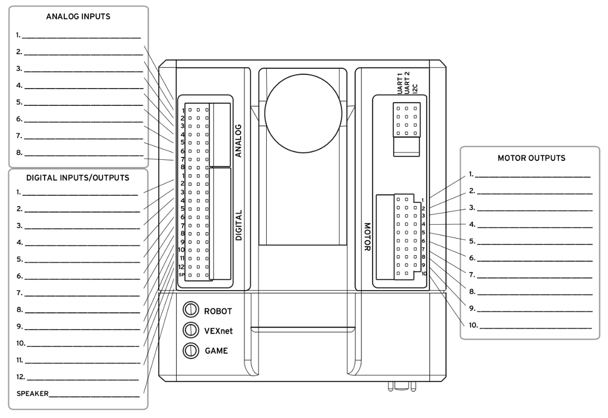
Notes (motors/sensors, modifications, special notes) ____________________________________________________________________________________________________________________________________________________________________________________________________________________________________________________________________________________________________________________________________________________________________________________________________________________________________________________________________________________________________________________________________________________________________________________________________________________________________________________________________________________________________________________________________________________________________________________________________________________________________________________________________________________________________________________________________________________________

Computer Programmer:
Use the PLTW template to develop the ROBOTC program. Copy and paste your pseudocode and computer code below.

